Social Studies Quarterly Assessment Review
- What is O^{O} degrees latitude called
- Australia is mainly in which two hemispheres
- Which ocean was the Columbian Exchange centered on?
- Rebirth is a French term that describes what?
- Explain the idea of humanism.
- Exploration was possible due to this time period.
- Why was the printing press such a revolutionary invention?
- Renaissance ideas were spread by which three methods?
- Define a “Renaissance Man.”
- _________________________________________ wrote the famous _______________________________ and nailed it to the Castle Cathedral door at Wittenberg, Germany.
- The relationship between England and the Catholic Church deteriorated or weakened because of this event:
- Explain the purpose of an indulgence.
- What made the European explorers want to go and explore new lands?
- Why was African Slavery used in the “New World?”
- Europeans began to feel superior over other ethnic groups. Why did this happen?

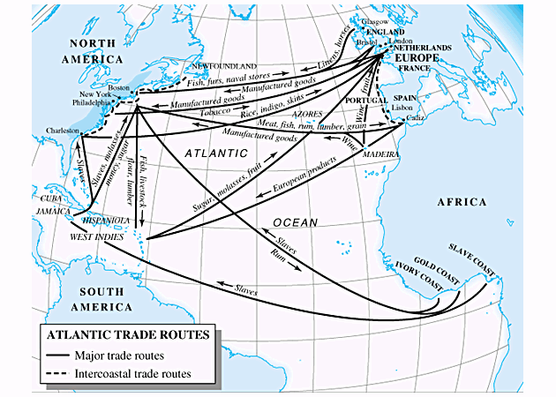

Below answer the following questions about Atlantic trade routes.
- Explain two positive effects of the Atlantic Trade Routes?

- Explain two negative effects of the Atlantic Trade Routes?

Below read the following passage and answer the last two questions.
Document 1: Columbus's diary
Saturday, 13 October. [1492] At daybreak great multitudes of men came to the shore, all young and of fine shapes, very handsome; their hair not curled but straight and coarse like horse-hair, and all with foreheads and heads much broader than any people I had seen; They came loaded with balls of cotton, parrots, javelins, and other things too numerous to mention; these they exchanged for whatever we chose to give them.
19. What did Columbus observe about the Natives?
20. What did the Spanish and Native Americans do together?
Document 2: Description of Aztec reaction to Cortez
Cortez was coming. Montezuma [leader of the Aztecs] had already sent wizards, magicians, and seers to cast spells that would destroy or at least deter the Spaniards from continuing towards the Capital. Their failure had re-confirmed the [Aztec] emperor’s opinion that these indeed, were the gods of legend
21. What did Montezuma send to Cortez?
22. Why might the Aztecs believe the Spaniards were gods?

