**Read the following selection and use the diagram to answer the corresponding question in complete sentences.**

**The Copernican Model: A Sun-Centered Solar System**

The Earth-centered Universe of Aristotle and Ptolemy held sway on [governed] Western thinking for almost 2000 years. Then, in the 16th century a new idea was proposed by the Polish astronomer Nicolai Copernicus (1473–1543).

**The Heliocentric System**

In a book called On the Revolutions of the Heavenly Bodies (that was published as Copernicus lay on his deathbed), Copernicus proposed that the Sun, not the Earth, was the center of the Solar System. Such a model is called a heliocentric system. The ordering of the planets known to Copernicus in this new system is illustrated in the following figure, which we recognize as the modern ordering of those planets….

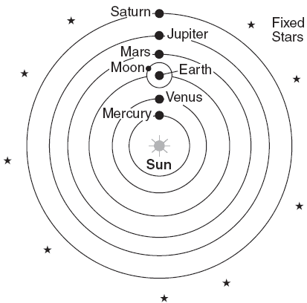

Source: The Copernican Model: A Sun-Centered Solar System, Department of Physics & Astronomy, University of Tennessee

Based on this document, how was Copernicus’s theory of a heliocentric solar system different from Ptolemy’s ideas about the universe?

**Read the following excerpt and answer the corresponding question in complete sentences.**

***. . . Gradually scientists came to challenge more and more what the ancients [past civilizations] taught. They came to develop new, better methods of finding out how things worked. Mathematical knowledge increased and helped them to reason. They began to think up experiments to check on their ideas in a methodical way. The scientific revolution had begun.***

***Many men were needed to bring this about. These men came from every part of Europe. They wrote books to explain their ideas. The printing press made it possible to produce thousands of copies which found their way all over Europe. Scientists were able to learn from one another and give one another new ideas. So the Scientific Revolution was not the work of Englishmen, or Frenchmen, or Italians alone. It was the work of Europeans. And, as we have seen, even they did not do it all by themselves. The Chinese, the Indians, the Persians, and the Arabs all gave something before it came about. Today this is not hard to understand, because men and women from all over the world add to scientific knowledge and so help one another. . . .***

Source: Peter Amey, Scientific Revolution, Greenhaven Press

Based on this document, explain **two** changes that resulted from the Scientific Revolution.

**Read the following excerpt and answer the corresponding questions in complete sentences.**

This is an excerpt from a letter written by Galileo Galilei in 1615 to the Grand Duchess Christina defending his approach to science.

***Some years ago, as Your Serene Highness well knows, I discovered in the heavens many things that had not been seen before our own age. The novelty of these things, as well as some consequences which followed from them in contradiction to the physical notions commonly held among academic philosophers, stirred up against me no small number of professors — as if I had placed these things in the sky with my own hands in order to upset nature and overturn the sciences. They seemed to forget that the increase of known truths stimulates the investigation, establishment, and growth of the arts; not their diminution [lessening] or destruction.***

***Showing a greater fondness for their own opinions than for truth, they sought to deny and disprove the new things which, if they had cared to look for themselves, their own senses would have demonstrated to them. To this end they hurled various charges and published numerous writings filled with vain arguments, and they made the grave mistake of sprinkling these with passages taken from places in the Bible which they had failed to understand properly, and which were ill suited to their purposes….***

Source: Galileo Galilei, “Letter to the Grand Duchess Christina (1615)”

1. According to Galileo, why is the search for truth important?
2. Which document did Galileo’s opponents use to support their opinions?

**Read the following excerpt and review the diagram to answer the corresponding question in complete sentences.**

…At first, the discoveries of Copernicus and Galileo upset many Europeans. Over time, however, a new way of thinking about science emerged. Scientists began to observe the world around them and to develop ideas about why things happened. They did experiments to test these ideas. This new way of thinking was called the scientific method….

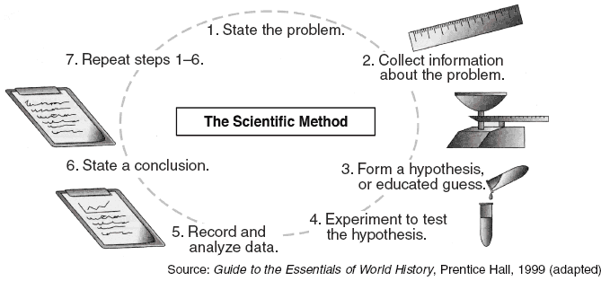

Based on this excerpt and diagram from Guide to the Essentials of World History, what is ***one*** way Copernicus, Galileo, and others influenced how scientists work?

**Use the cartoon about the Church’s treatment of Galileo and the quote from Galileo to answer the questions in complete sentences.**

|  |
| --- |
| http://thesituationist.files.wordpress.com/2007/12/galileo-image-by-marc-scheff.jpg |

**“With sincere heart and unprecedented faith I (reject)…, and detest the aforesaid errors and heresies (lies) of Copernicus and also every other error…contrary (opposite) to the Holy Church, and I swear that in the future I will never again say or assert…anything that might cause a similar suspicion toward me.” - Galileo**

1) What “truth” was discovered by Galileo that is depicted burning in the fire with him?

1b) Why is word “fear” shown in the background of the shadows of the church officials?

1c) Why would Galileo have made the statement above?

**Use the following ancient diagrams of the universe showing the relationship between the planets and the sun and the excerpt below to answer questions 1-3 in complete sentences.**

|  |
| --- |
| ptolemy_cosmos  Ptolemy’s Geocentric Model  http://scienceblogs.com/startswithabang/upload/2010/09/geocentrism_was_galileo_wrong/Copernicus_solar_system.gifCopernicus’ Heliocentric Model |

|  |
| --- |
| **Although backed by authority and common sense, the geocentric theory did not accurately explain the movements of the sun, the moon, and planets. This problem troubled a Polish cleric and astronomer named Nicolaus Copernicus. In the early 1500s, Copernicus became interested in an old Greek idea that the sun stood at the center of the universe. After studying planetary movements for more than 25 years, Copernicus reasoned that indeed, stars, the earth, and other planets revolved around the sun.** |

**Source: World History by McDougal Littell**

1. What is the major difference between the heliocentric model and the geocentric model? Why might people have problems accepting Copernicus’ model?

1. What ideas did Copernicus call into question?
2. How does the excerpt portray Copernicus as a Renaissance humanist?