Warm Up February 11th – March13th
February 11th/12th – Without consulting your notes please give 3 causes of Imperialism out of the 5 we learned. If you can recall 4 or 5 please do!
February 17th/18th – NO SCHOOL ICE STORM! (2 days)
February 19th/20th - As you completed the review which topic did you have the most difficulty with? What specific questions did you struggle to understand? (Look at your review to help you)
February 23rd/24th –
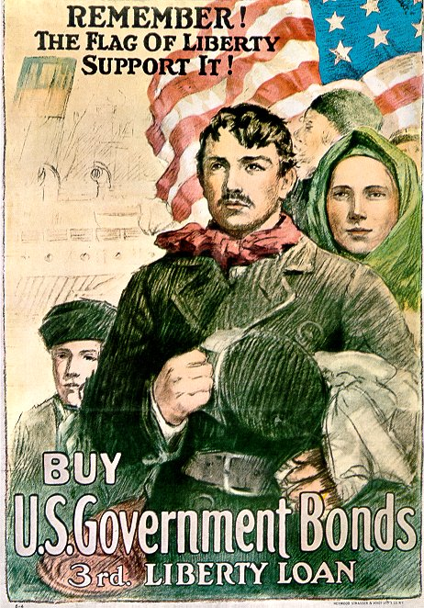
The poster above is showing an example of what main idea we learned about last week? What evidence do you have that led you to your conclusion? Be specific.
February 24th/25th – What do you already know about WWI? If you aren’t sure make a hypothesis. Try to give at least two details.
March 11th/13th - In your own words explain WWI. What do you believe was the main cause of the war? Give evidence to support your answer.

